Atria Institute of Technology



**Department of Information Science and Engineering**

**Big Data Analytics (18CS72)**

**Assignment-1**

**SUBMITTED BY**

Name: Swarna A V

USN: 1AT20IS098

Section: B

Submission Date: 27/11/2023

**Course Handling Faculty Name:**

Dr. K S Ananda Kumar

Associate Professor

Dept of ISE, Atria IT.

**Table of contents**

|  |  |
| --- | --- |
| **Sl. No** | **Description** |
| 1 | 1. create an **EC2 Linux** instance in AWS Cloud /Any cloud  INSTANCE NAME - **YOUR NAME**  INSTANCE TYPE - t2.micro/any other also.  key pair name- your name  storage - 10 GB  Take the screenshot of instance running status  Mention the private IP address and Public IP address.  (Execute this program/concept and take a screenshot of the output) |
| 2 | Execute the basic Linux commands/ simple program on the instance  (Execute this program and take a screenshot of the output) |
| 3 | Create the **GitHub** Account with your credentials, Same things stored in public repository in Github. Share the assignment in github link. |

**Note:**

1. Minimum 10 Screenshots with proper explanation
2. Minimum no of pages – 10
3. Submit your Assignment soft copy (Word & PDF) to [anandakumar.ks@atria.edu](mailto:anandakumar.ks@atria.edu).

**Subject Line in mail:** Student_Name_USN_BDA_Assignment1

1. Share your assignment Github link in Assignment Document.
2. Submit Assignment on or before **27th Nov 2023.**

**Instance Creation-01**

I have created an Instance using Google Cloud.

We can achieve it through Google Computing Engine(GCE) which is equivalent to ec2 instance in AWS.

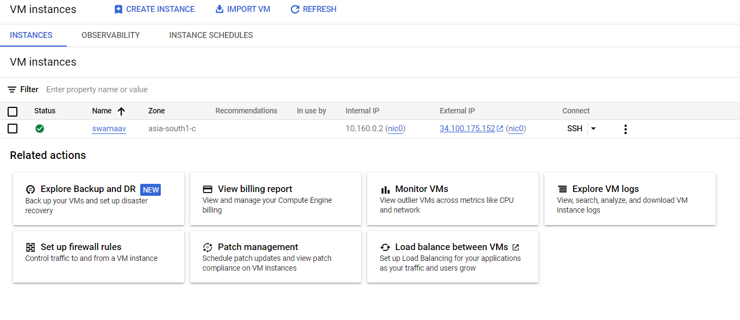

The above picture shows the depiction of the instance being created.

The instance is the name : swarnaav

Internal (Private)IP:10.160.0.2

External (Public)IP:34.100.175.152

Instance ID:7959077807165374016

The following pictures show basic description of the instance. 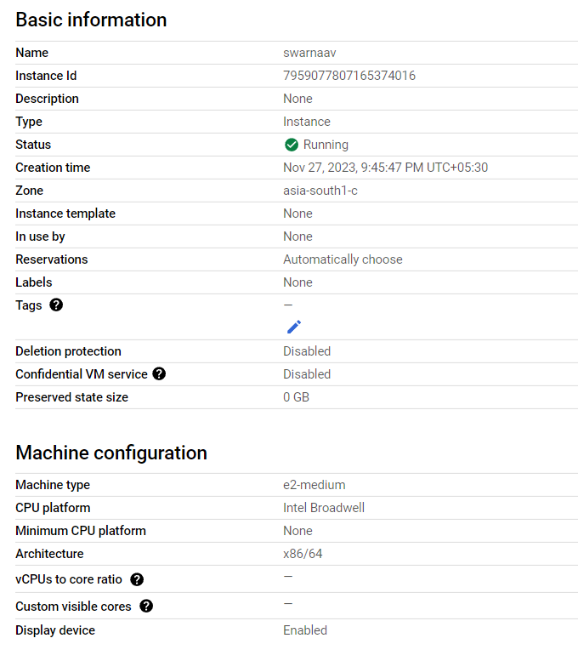

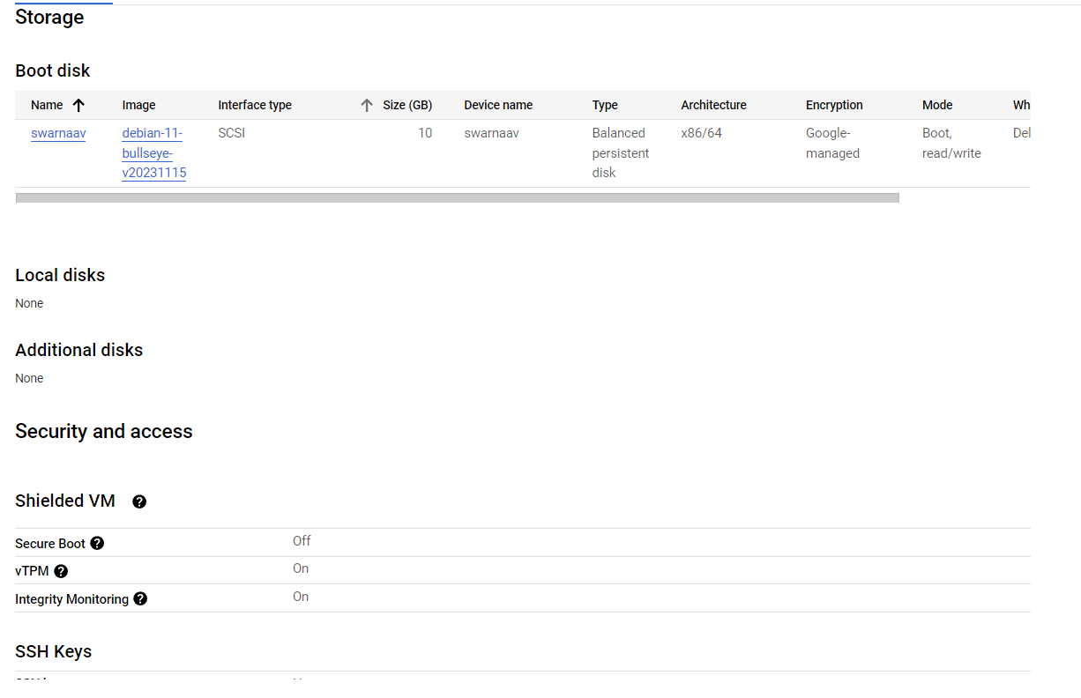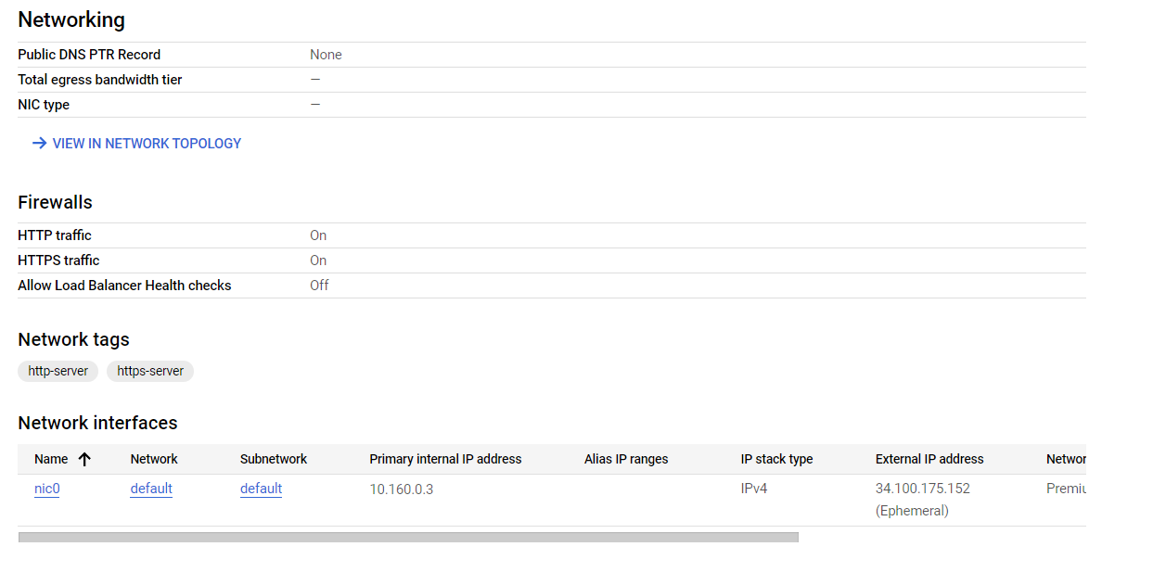

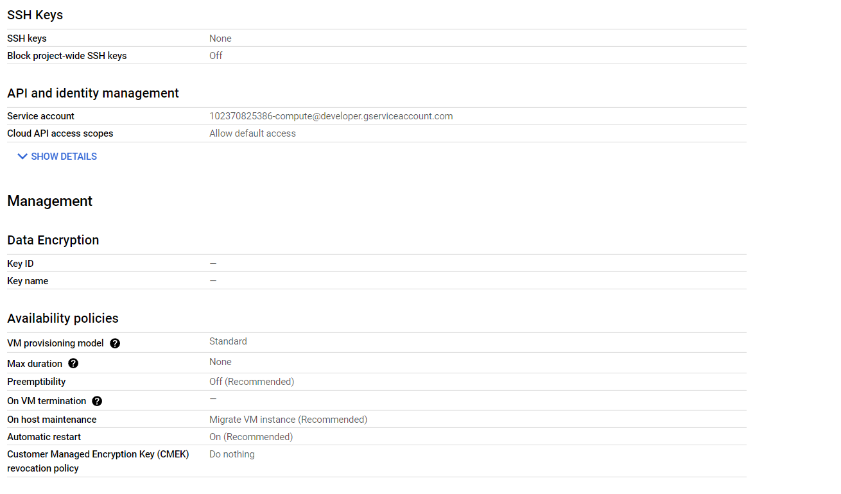

The screenshots give an overview of the configurations used in the VM.

**Running sample Program on Linux Instance**

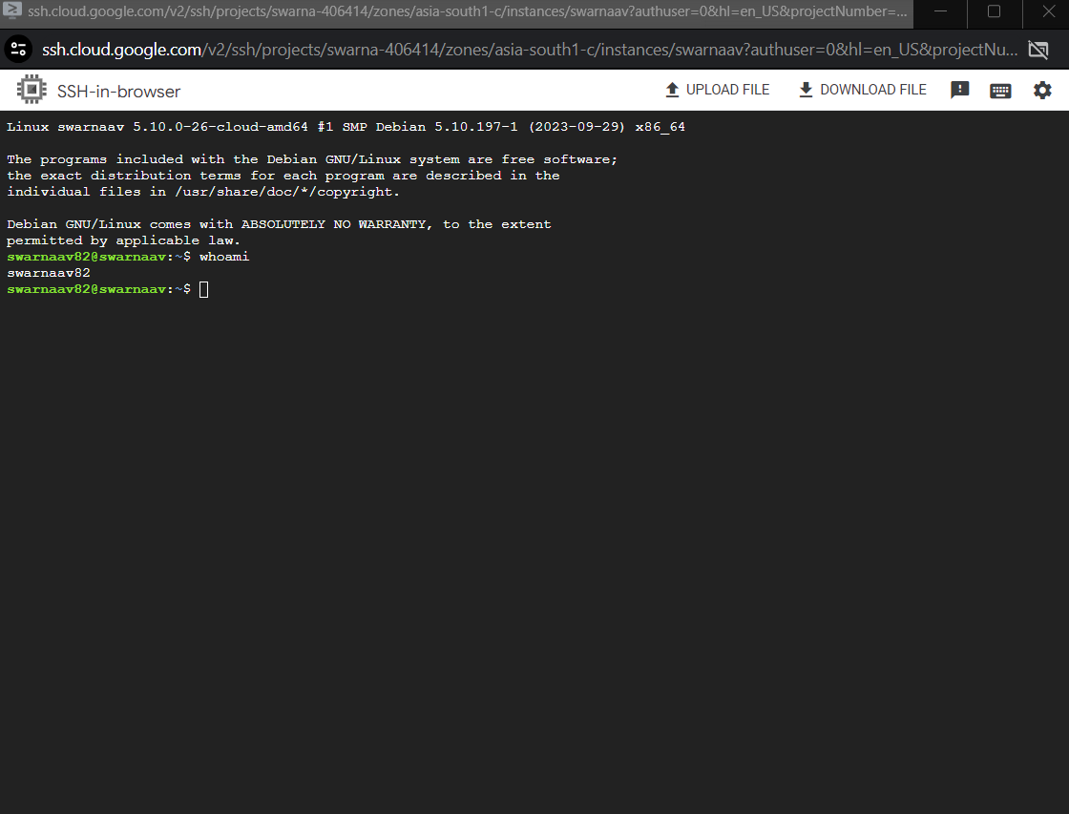

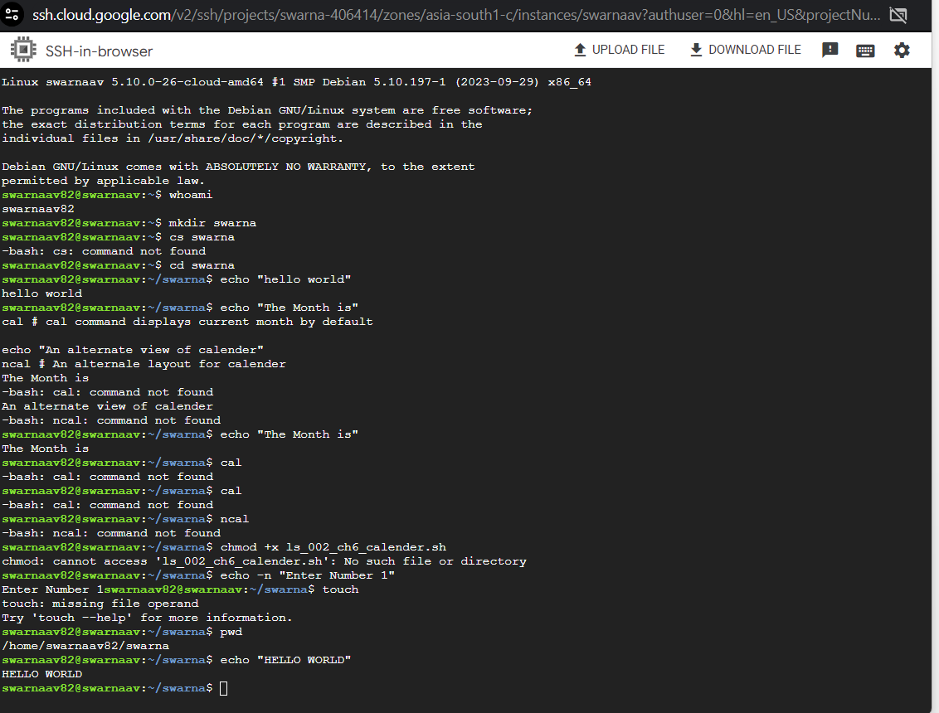

We can observe that a number of LINUS commands are executed in the above image.

We can run this via browser using the SSH connection.

This shows the utilization of the resources at the end of the project.

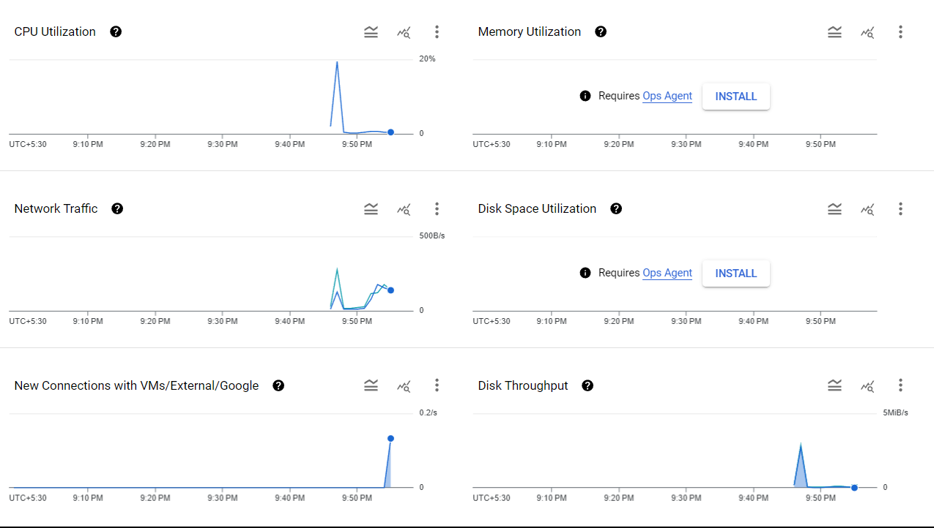

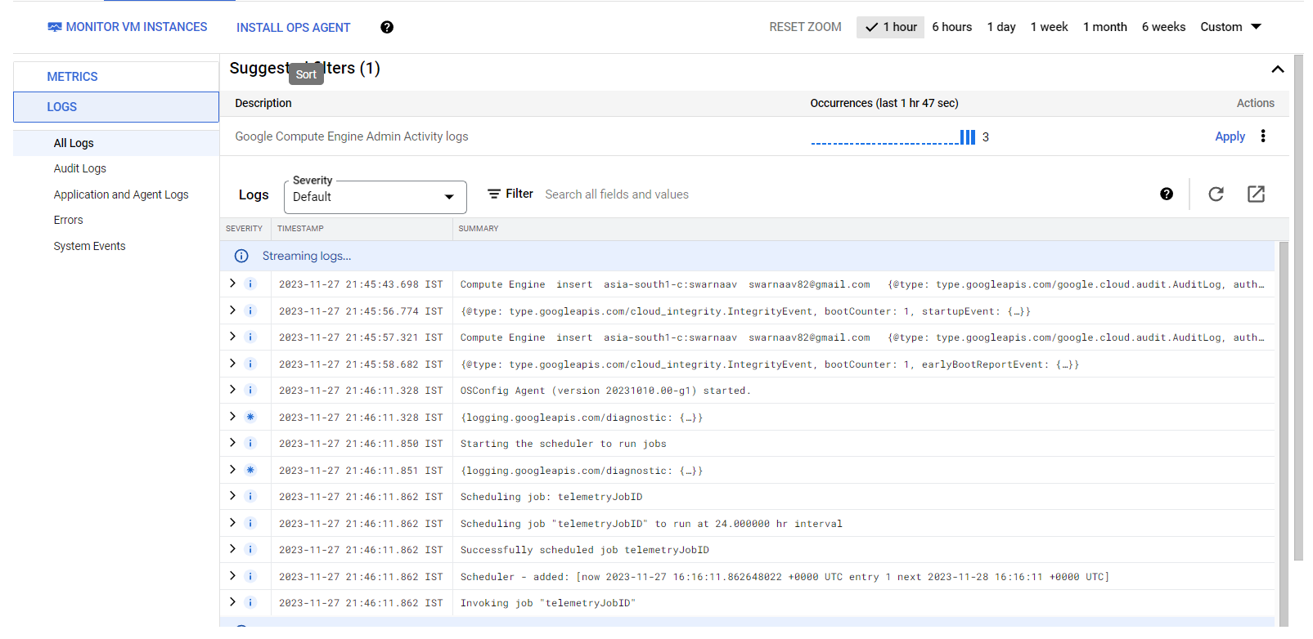

**Assignment GitHub Link (**[**https://github.com/login**](https://github.com/login)**). (using this link able to access your work)**